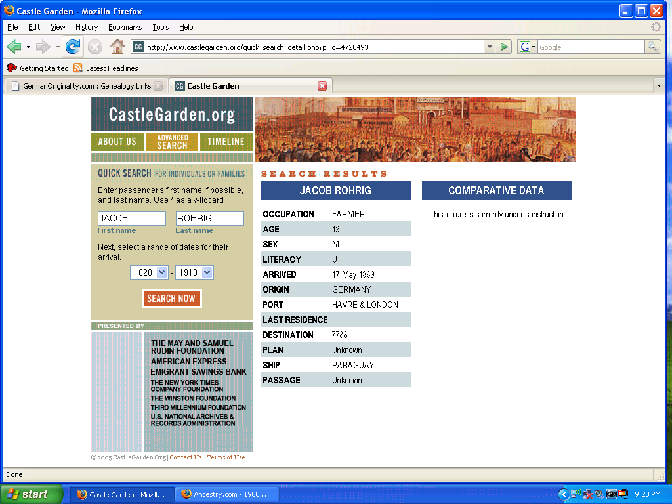

Name: Jacob Roch
[Jacob Roehrig]
Arrival Date: 17 May 1869
Estimated Birth Year: abt 1849
Age: 20
Gender: Male
Port of Departure: Le Havre, France and London, England
Destination: New York
Place of Origin: Bavaria
Ethnicity/Race-
/Nationality: Bavarian
Ship Name: Paraguay
Search Ship Database: Search the Paraguay in the 'Passenger Ships and Images' database
Port of Arrival: New York
Line: 43
Microfilm Serial: M237
Microfilm Roll: M237_310
List Number: 513
Port Arrival State: New York
Port Arrival Country: United States

